Sprint 1 and 2 - Endurance Design Document

October 2019-December 2019

By: Kayleigh Rucinski/Ava Taylor/Emily Tumbaco

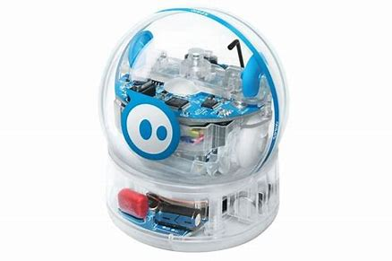
Table of Contents
1. Executive Summary 3
1.1 Project Overview 3
1.2 Purpose and Scope of this Specification 3
2. Product/Service Description 3
2.1 Product Context 3
2.2 User Characteristics 3
2.3 Assumptions 3
2.4 Constraints 4
2.5 Dependencies 4
3. Requirements 4
3.1 Functional Requirements 4
3.2 Security 4
3.2.1 Protection 4
3.2.2 Authorization and Authentication 5
3.3 Portability 5
4. Requirements Confirmation/Stakeholder sign-off 5
5. System Design 6
5.1 Algorithm 5
5.2 System Flow 6
5.3 Software 6
5.4 Hardware 7
5.5 Test Plan 7
5.6 Task List/Gantt Chart 7
5.7 Staffing Plan 7

Executive Summary

Project Overview
This point of this project is to code a Sphero robot to go through multiple tasks. These tasks include testing endurance, speed, and agility. The endurance test is to make the robot move in a rectangular shape around the room, without hitting any objects or walls. The speed test is to get the robot to maneuver in a figure eight shape, while staying on track. The agility test is to get the robot to make it through an obstacle course. This course includes a ramp, knocking down pins, and maneuvering between milk jars. The intended audience of this project is people interested in problem solving. The entire project is based off of being given the problems, also known as the tests, and the coders have to solve it by coding in JAVA.

Purpose and Scope of this Specification
In scope-what is going to happen
- Agility test (described in description below)
- Endurance test (described in description below)
- Speed test (described in description below)
Out of Scope(out of the project)
- Having the robot open and close a door
- Having the robot sing while going through an obstacle course
- Having the robot hop off of a table onto the floor
The purpose of this entire project is to test if the group can write code that maneuvers the Sphero robot for the intended purposes. For example, the point of the endurance test is to move in a rectangular motion throughout the room, while not hitting any walls or objects. The speed test is intended to test if the code gets the robot to move in a figure eight motion, while staying on the taped marks. Lastly, the agility test is to test if the code makes the robot go through the obstacle course, while only knocking down the pins.

Product/Service Description

Product Context
This project is very original compared to the other projects that the class has done. This project is going to be coded in JAVA and will run independently. The task is to code the program prior to the presentation. This means that the robot will follow the program to complete the three tests, without the help of the members.

User Characteristics
For the customers using this product, staff, students, and faculty will need little experience with coding. The user needs to understand how to problem solve in a thoughtful manner to be able to plan the code in an efficient way. The application uses JAVA, which has a form of puzzle piece coding. This makes it simpler to use and more usable for people with less coding experience. Also, the application that connects to the robot gives tutorials and helpful hints as to how to use them.

Assumptions
Some assumptions that affect the requirements may include the availability of the robots, having a Bluetooth device that works, and the extend of the users coding experience. The robots are shared among many users, so the availability of the robot affects the users experience. Also, the ability to work with the robot is dependent on the user’s access to a Bluetooth device. With no Bluetooth device, the robot will not work. Lastly, if the user does not understand some basics of coding, it will make it extremely hard to be able to do this project. Some coding experience is needed to be able to get the robot to work efficiently.

Constraints
The robots supplied are seemingly awkward to maneuver. When rotating the robot, the base of the robot accommodates to the rotation. This means that when the robot is moving and makes a stop, it is going to wobble around, potentially hitting an object or wall. A way to accommodate for this would to be guess how much it wobbles by taking an average, but it is not a perfect science. Also, the robots need to have a protective case on them, which can cause some awkward movements, but nothing astronomical. The robots are also not always available. They are shared among many classes, making the project not always accessible. Lastly, the robot needs to connect by Bluetooth, which means that the robot can only go so far from the computer. This means that the size of the sprints is limited.

Dependencies
- This product requires about three hours to charge.
- This product is fragile and could potentially break in the testing phase.
- This product is covered in a case, causing it to maneuver weirdly at times.
- The product needs to connect by Bluetooth and only can more a certain distance away (depends on device with how far it can go)
- The product maneuvers awkwardly, causing it to wobble and potentially hit objects.

Requirements

Functional Requirements (For sprint one and two)

Req# | Requirement | Comments | Priority | Date Rvwd | SME Reviewed / Approved
Sprint 1 | Turns green | Starting position | 1 | 10-22-19 | KR
Sprint 1 | Says “Ready, Set, Go | Make sure laptop volume is on | 2 | 10-22-19 | KR
Sprint 1 | Moves around perimeter of course | Make sure robot stays within the figure eight tape marks | 3 | 10-22-19 | KR
Sprint 1 | Stops | Ends in same spot it started | 4 | 10-22-19 | KR
Sprint 1 | Turns red | Prepare for test to be finished | 5 | 10-22-19 | KR
Sprint 1 | Says “I’m done and I need water” | Put robot away | 6 | 10-22-19 | KR
Sprint 2 | Start on “X” provided in course | Make sure the aim is set up facing the direction of the course | 1 | 11-11-19 | KR
Sprint 2 | Run figure eight path, without straying from course | Watch robot | 2 | 11-11-19 | KR
Sprint 2 | Run figure eight path, without straying from course | Watch robot | 3 | 11-11-19 | KR
Sprint 2 | Run figure eight path, without straying from course | Watch robot | 4 | 11-11-19 | KR
Sprint 2 | Run figure eight path, without straying from course | Watch robot | 5 | 11-11-19 | KR
Sprint 2 | Run figure eight path, without straying from course | Watch robot | 6 | 11-11-19 | KR
Sprint 2 | Finish on the same “X” that the robot started on | Look for the “X” marking | 7 | 11-11-19 | KR
Sprint 2 | Speak “I am the winner!” | Make sure computer volume is on loud enough (varies computer to computer) | 8 | 11-11-19 | KR
Sprint 2 | Flash muti-colored lights for five seconds | Pick up robot | 9 | 11-11-19 | KR

Security

Protection
- The code for the tests is on each member’s personal laptop. This means that if someone took the robot, the code is still with the person. The person can then take another robot and use the same code. The only way for a person to get the code is to take the person’s laptop and get past the team’s passwords.

Authorization and Authentication
- Authorization is being able to connect to the robot. The user needs the number of the robot to be able to connect to the right one.
- The user also needs the laptop with the code on it, which is password protected.
- With no password to a member’s laptop, they will not have the code. (Our code is on private mode on the Sphero app)

Portability

Robotic interface written in JAVA provides an easy way to transport the code. The code can be executed on multiple devices, platforms and operating systems. JAVA has been selected because it is the industry leader is platform independence. The robot is preprogrammed to work by itself, but the team codes it to manipulate the directions it moves. Since this is run by Bluetooth, the system is also reusable to other robots.

Requirements Confirmation/Stakeholder sign-off
Include documentation of the approval or confirmation of the requirements here. For example:
Meeting Date | Attendees (name and role) | Comments
10/27/19 | Kayleigh-Design document and Gantt chart  Ava-code and flow chart | Emily missed sprint meeting due to family reasons. We wrote the code, tested it, and made the design document.
11/8/19 | Kayleigh-Design document updates (updating the previous one to make it applicable for sprint two)  Ava-writing of the code (to get the robot to make the figure eight motion)  Emily- reviewing of the design document for any errors, creation of the Gantt chart | Code was somewhat pre-written and the point of this meeting was to test it and to get the exact measurements needed. All team members were in attendance sprint was partially completed.
11-11-19 | Kayleigh-Design document updates (updating the previous one to make it applicable for sprint two)  Ava-testing of the code (to get the robot to make the figure eight motion and stay on the intended track)  Emily- reviewing of the design document for any errors, creation of the Gantt chart | Code was pre-written and the point of this meeting was to test it and see if the robot completed the task. All team members were in attendance and sprint was completed.

System Design

Algorithm
Develop and describe here the algorithm that will be used to provide the required performance of your software
- Start on “X” provided in course
- Run figure eight path, without straying from course
- Run figure eight path, without straying from course
- Run figure eight path, without straying from course
- Run figure eight path, without straying from course
- Run figure eight path, without straying from course
- Finish on the same “X” that the robot started on
- Speak “I am the winner!”
- Flash multi-colored lights for five seconds

System Flow- Sprint 1 and 2
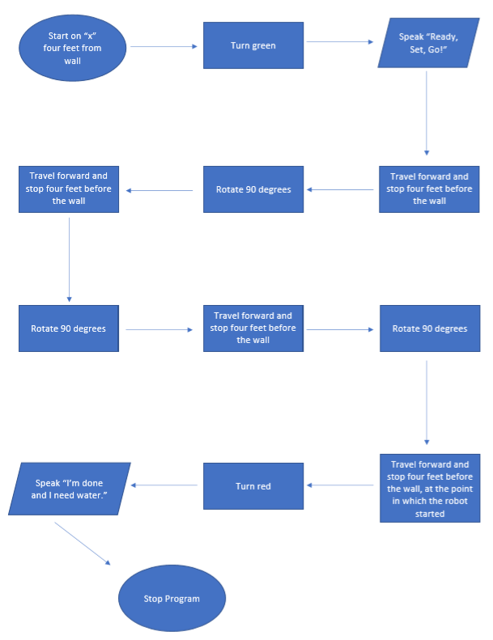

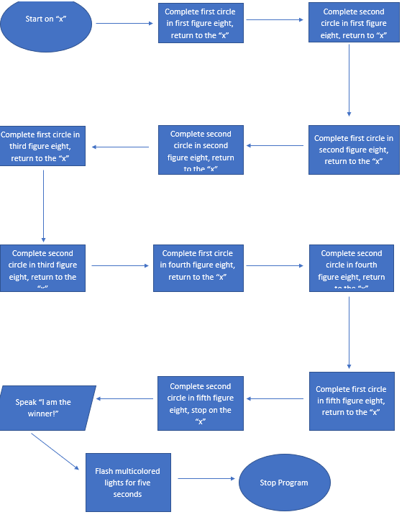

Software
Throughout this project, JAVA, Bluetooth, and Sphero are the types of software used. Sphero is the application that controls the robot and has preprogrammed it to work with JAVA. JAVA is the coding source that we used to control the directions the robot moved and what it said. Bluetooth is how we connected our laptops to the robot. This is what made Sphero and JAVA be able to make the robot move.

Hardware
Our project supports all sorts of hardware. Throughout our group we use Windows and Mac laptops. We tested code with the Windows laptop, since the Bluetooth connects for a longer distance.

Test Plan

Reason for Test Case | Test Date | Expected Output | Observed Output | Staff Name | Pass/Fail
First attempt at code for Sprint 1 | 10/27/19 | Robot made its way around the room. This means without hitting objects or walls, all while staying four feet away. | Robot completed expected output. | Kayleigh and Ava | Pass
First attempt at code for Sprint 2 | 11-8-19 | Robot is supposed to start on provided “X”, then maneuver in a figure eight motion at least one time. | Robot would move in a figure eight motion, but kept falling off course. The figure eight shape was too large. | Ava, Kayleigh, and Emily | Fail
Second attempt at Sprint 2 | 11-10-19 | Robot is supposed to start on provided “X”, then maneuver in a figure eight motion at least one time. | Robot finally moved in a figure eight motion and kept itself on the course. The shape was made correctly. | Ava, Kayleigh, and Emily | Pass
Third attempt at Sprint 2 | 11-11-19 | Robot is supposed to start on provided “X”, then maneuver in a figure eight motion for five times. This is done continuously. | Robot completed the course five times, but each run made the robot stray away from the course more and more. | Ava, Kayleigh, and Emily | Pass
Fourth attempt at Sprint 2 | 11-11-19 | Robot is supposed to start on provided “X”, then maneuver in a figure eight motion for five times. This is done continuously. | Robot completed the course the same way as last time and did not finish completely on the “X” | Ava, Kayleigh, and Emily | Pass

Task List/Gantt Chart
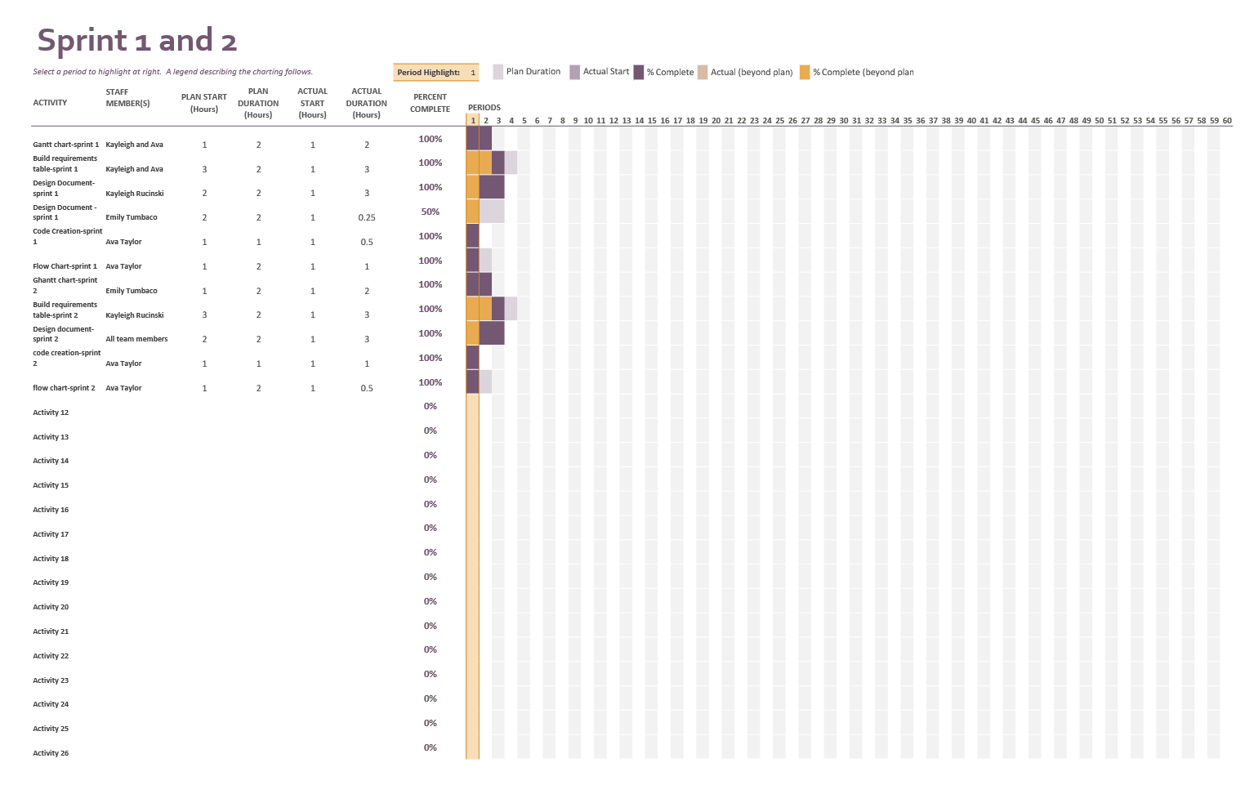

Staffing Plan
Insert a chart/table that depicts the roles and responsibilities of each team member that worked on this project

Name | Role | Responsibility | Reports To
Kayleigh | Design document and Gantt chart | Formatted and completed the design document. She watched the sprint take place to be able to understand the parameters and the details that need to be included. | Ava
Emily | Design Document | Did the revising of the design document. She checked for spelling errors and made sure that all topics were covered with enough detail. | Ava
Ava | Code and Flowchart | Wrote code for robot and tested it during the meeting. She made multiple adjustments to the code to get the sprint to work numerous times. She also created the flow chart as to follow the algorithm. | Ava

